1914
World War One Timeline

June 28- Franz Ferdinand archduke heir to the throne of the Austro-Hungarian Empire, and his wife are assassinated in Sarajevo, Serbia.
He is killed because people don’t like him. He made it clear that if he became Emperor there, he will make some changes. A Serbian terrorist group called the Black Hand decided that Archduke Franz Ferdinand should be assassinated. Their intention to kill Franz Ferdinand was a fail, until another terrorist named Gavrilo Princip fired two shots. The first bullet hit the pregnant Sophine in the stomach, she almost died instantly and the second bullet hit Archduke Franz Ferdinand in the neck.
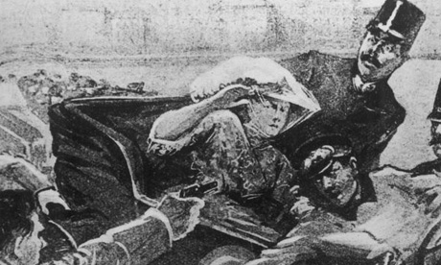
July 28- Emperor Franz Joseph of
Austria-Hungary declares war
On Serbia.
Because the terrorist of Serbia killed
Franz Ferdinand and his wife, which happens
To be Austrians, they made Emperor Franz
Joseph angry and eager to declare war with
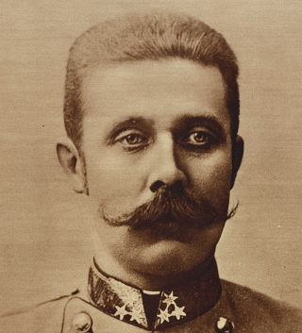
Serbia.

August 4- Germany declares war with Neutral Belgium
Germany declares war on neutral Belgium and invades in a right flanking move designed to defeat France quickly. As a result of this invasion, Britain declares war on Germany.

August 22- The Battle of the Frontiers
From the battle of Frontiers 27,000 French
Soldiers die on this single day in an offensive
Push to the east of Paris, towards the
German borders.
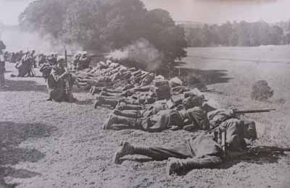

1915

January 19- War becomes "Total War" with German Zeppelin air raid on England
This event is a strategy for German to bring pain to England. During that time Emperor Wilhelm 2nd gives them permission, allowing them to do an air raid. So two Zeppelin navel airships 190 meters long flew over the east coast of England and bombed great Yarmouth and King’s Lynn. The raid killed 28 people and injured 60 more, there are also some important buildings were damaged in England, it is to avoid their improvement. They are using the Zeppelin which was developed in 1914 could reach a maximum speed of 136 kph and reach a height of 4,250 meters. The Zeppelin had five machine-guns and could carry 2,000 kg of bombs.
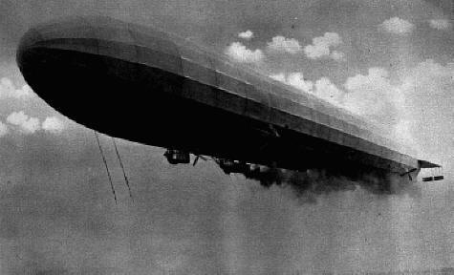

May 7- U-boat sinks the Lusitania.
The event where Germany launched 2 or
3 torpedoes to blow up a boat that kills
1,198 civilians, and that includes 128
American who died because of it.

September 15- the miss-use of weapons by British
British use gas in battle near Loos, but shifting winds cause 60,000 British casualties.

December 28- Allies begin
Withdrawal of troops
From Gallipoli.

1916

February 21 – December 18- Longest battle of the war
The longest battle of the war, the battle of Verdun is fought to a draw with an estimated one million casualties.
The Battle of Verdun in 1916 was the longest single battle of WW1. The battle of Verdun is a war between Germany and France. The Battle of Verdun started on February 21st 1916 and ended on December 16th in 1916. The attack on Verdun (the Germans code-named it Judgment) came about because of a plan by the German Chief of General Staff. He wanted to attack the France by launching a huge German attack on the land. The area around Verdun contained twenty major forts and forty smaller ones that had historically protected the eastern border of France and had been improved in the early years of the Twentieth Century.
April 19- US President Wilson
Publicly warns Germany not to
Continue unrestricted submarine
Warfare policies

July 1 – November 18- Battle of Somme
The battle of the Somme results in an estimated one million casualties and no breakthrough for the Allies. British introduce the tank, an effective weapon but far to few to make much of a difference.
ecember 31- Death of a Russian
Advisor
Rasputin, the self-avowed holy man and
Confidant to the Tsarina, is murdered by
Relatives of the Tsar.

