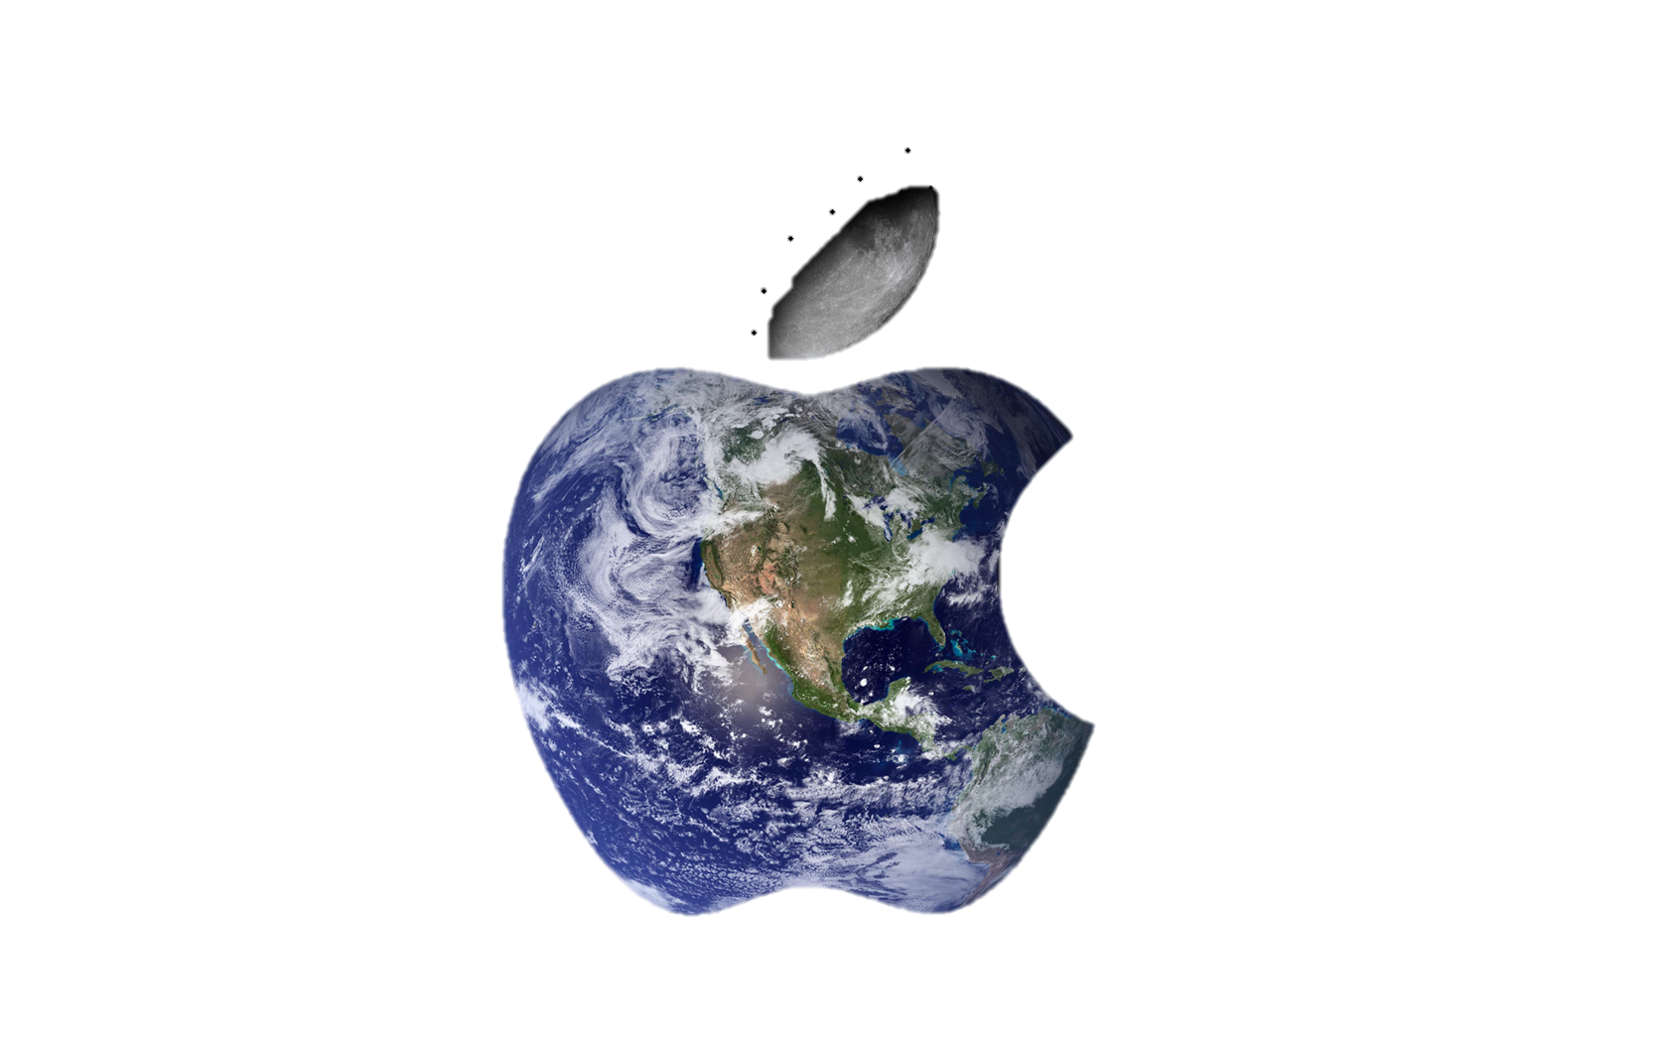
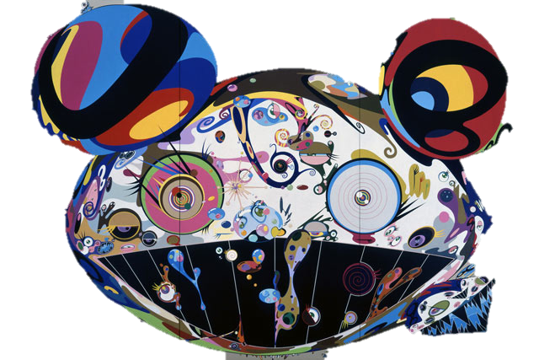
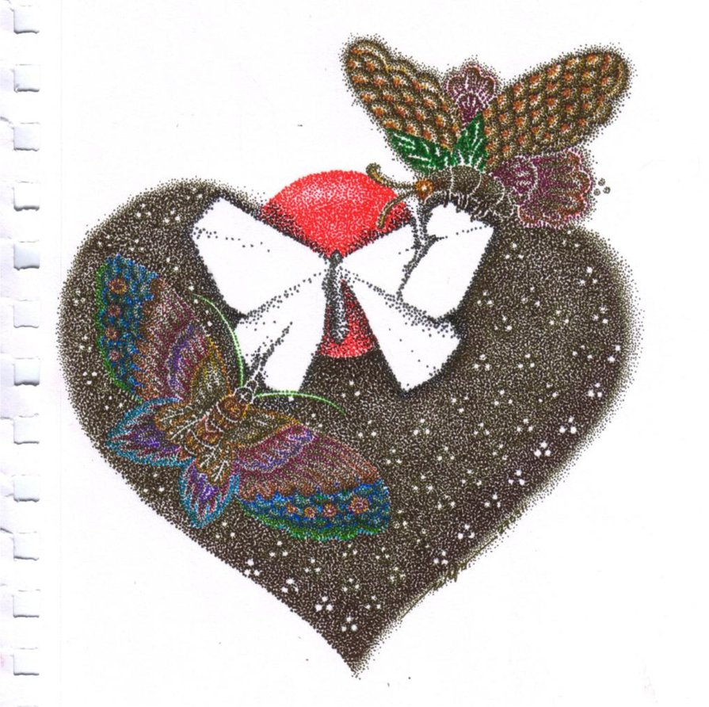
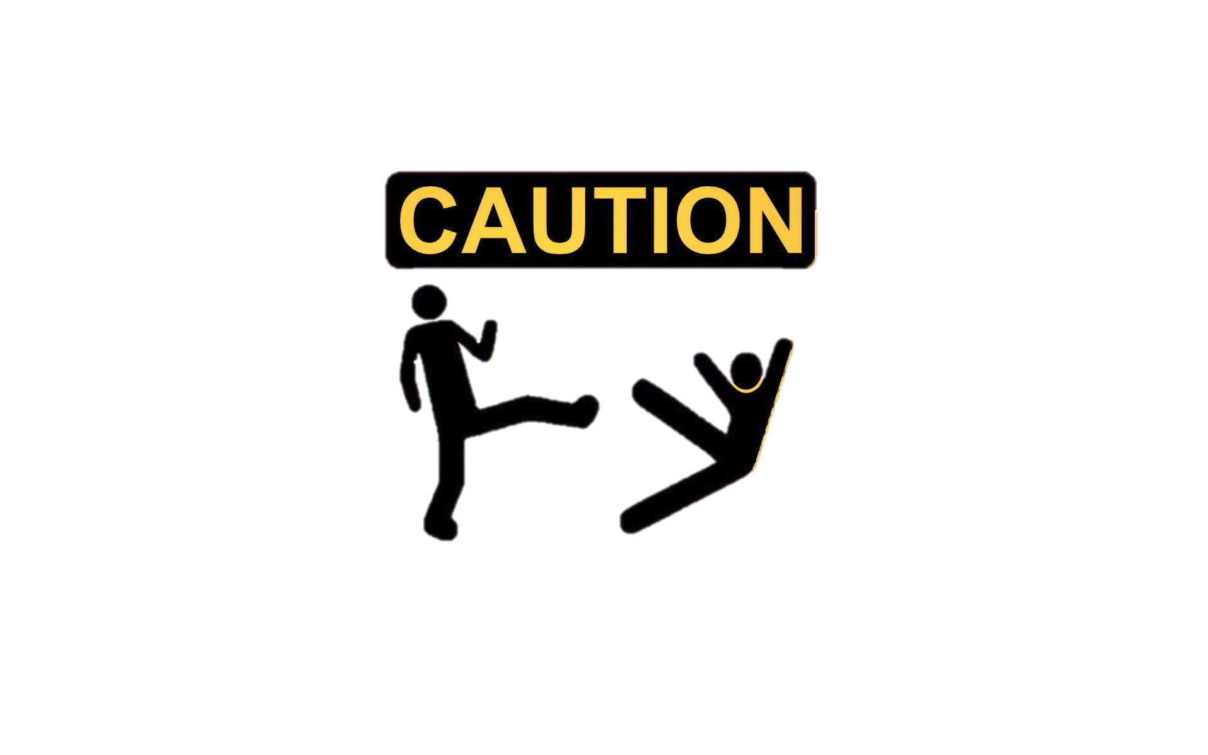
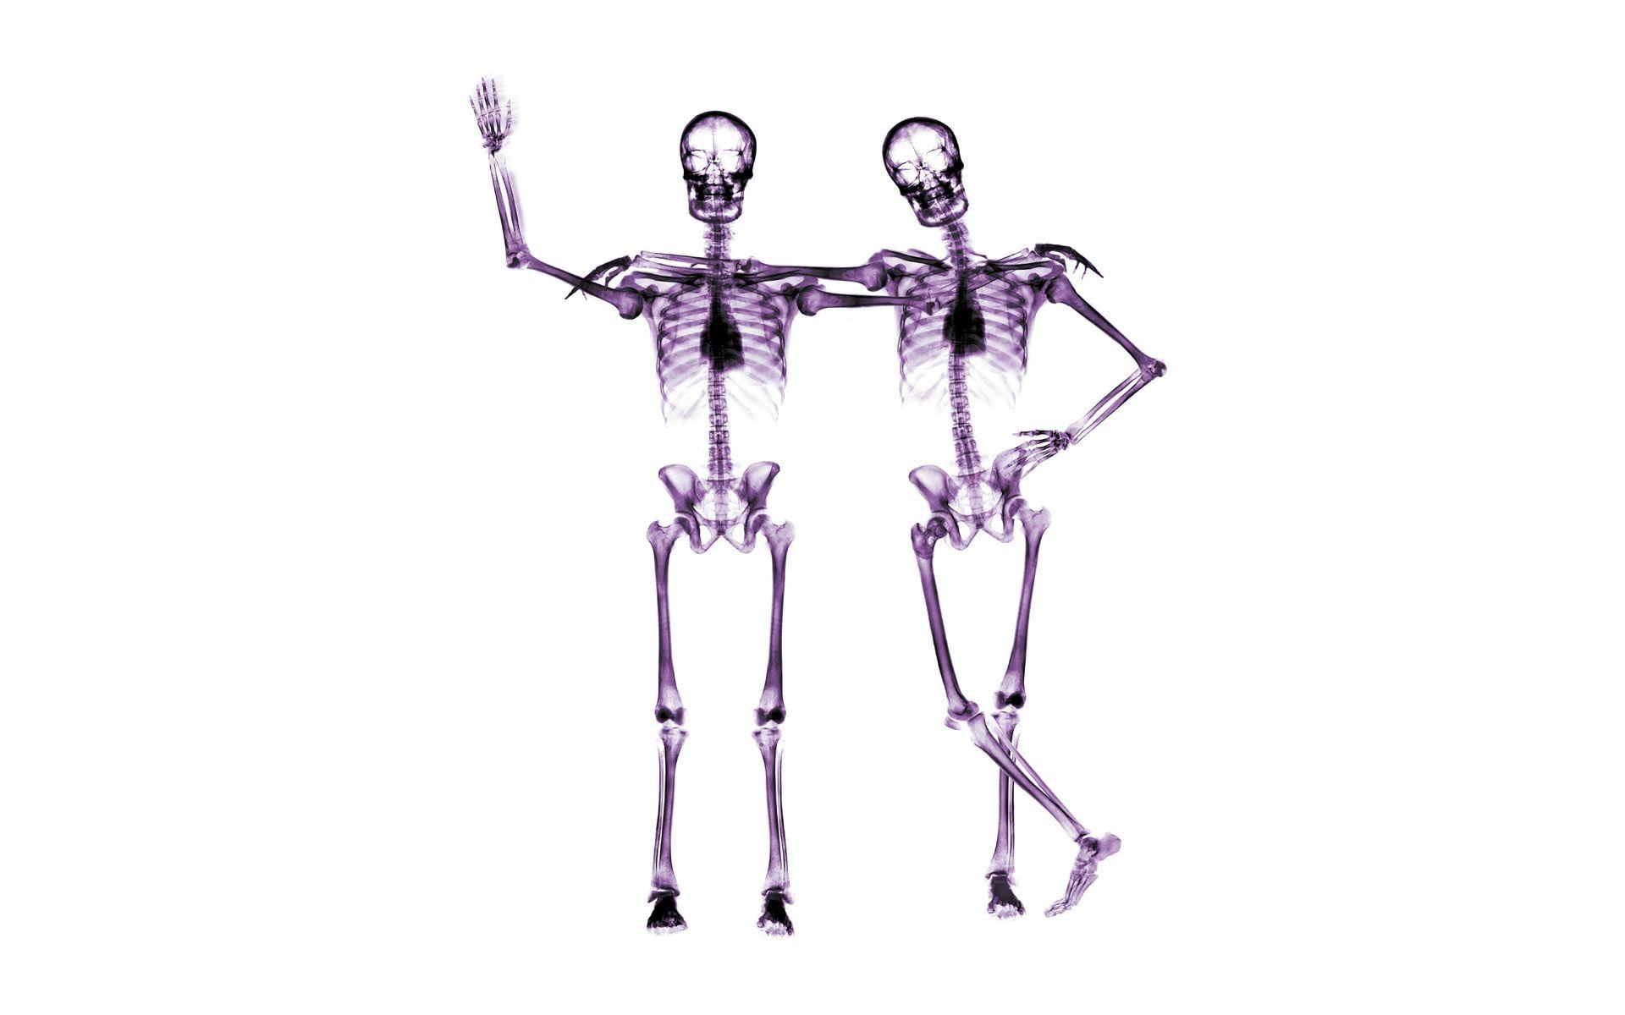
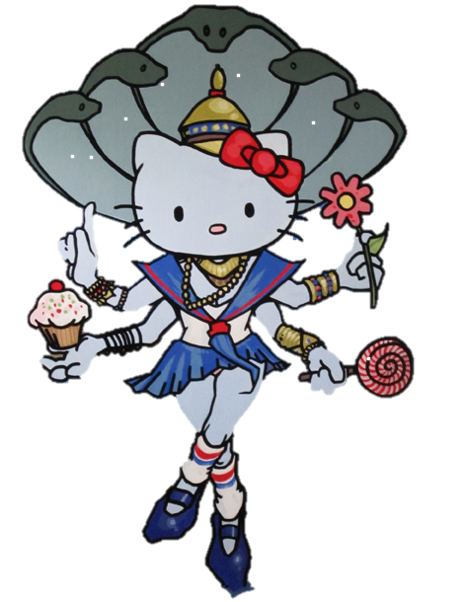
Who Am “i”??

Table Of Contents
Back To Japan 3
The Great Reef 4
I’m Thinking of Ribs 5
How to? I wanna be a billionaire 6
Misery!! 7

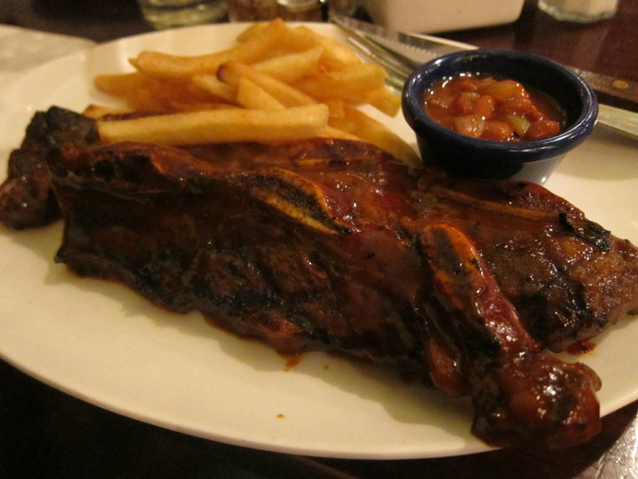
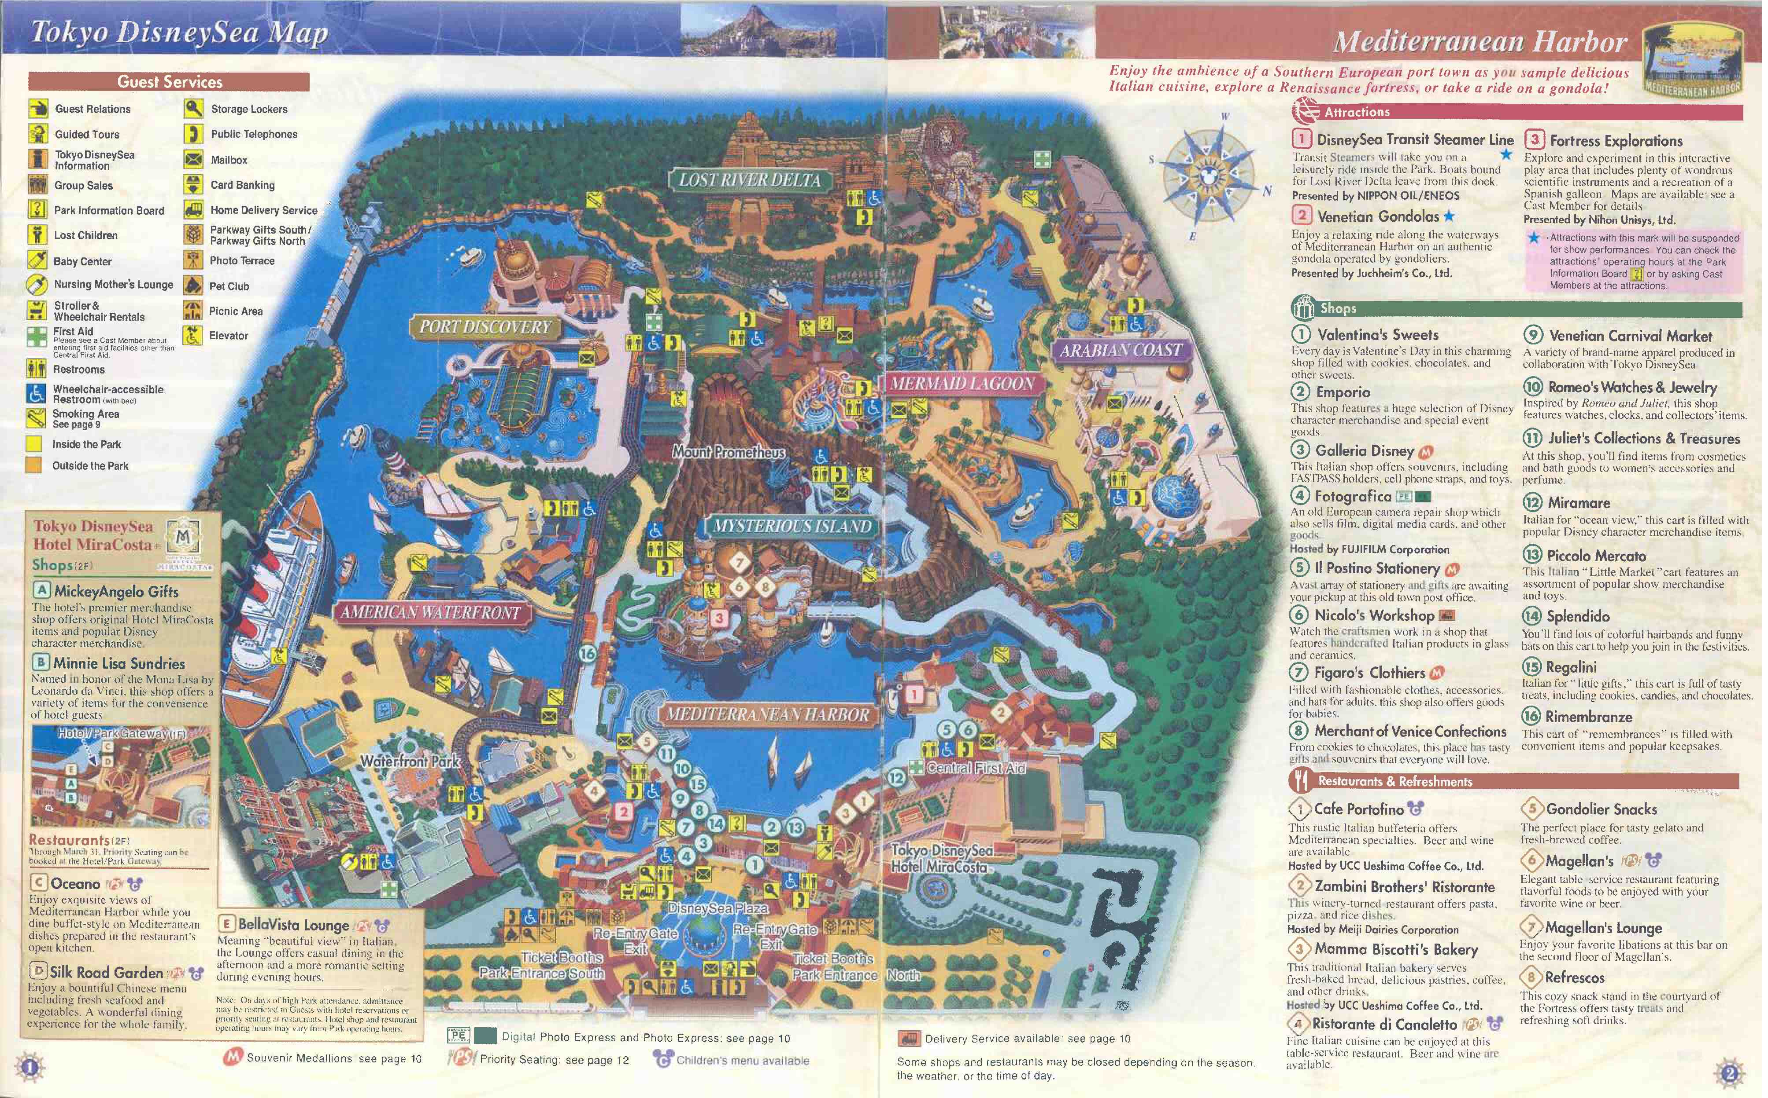

BACK TO JAPAN!

Memories. Memories are worth to keep. Memories are flowing in my head. Every single events happened in my life were recorded in my mind, so what ever happened in my life, I could retell it.
Well, Disney Sea in Tokyo, Japan is a memory that always stuck in my head, like a parasite (creature) stuck in another creature. I remembered all those things in Disney Sea, the black pepper popcorn, the attraction, the merchandise, and the mascot. Uh really, if I were a scientist, I would make a time machine, so I could travel back in 2010 when I was grade 5. It was so amazing that make me want to travel back to Disney Sea when I was grade 5. I love theme park, and Disney Sea it the most exciting theme I’ve ever visit.
I remembered the black pepper popcorn; the smell of the popcorn was traveling into my nose and into my head. The smell of the popcorn was spinning in my head, like I’ve been hypnotized. I remembered the taste of the popcorn. Black pepper mixed with crunchy popcorn, salt, and all other ingredients. Cheap popcorn is more precious than 5 star foods.
I could also remember the scream of the Japanese man and woman when they were riding a thrilling rollercoaster “Journey to The Center of The Earth”! I saw people putting their hands up in the air and I saw woman’s hair flowing in the air. Their faces are pale as a dead person. The speed of the rollercoaster was as fast as the speed of light. I saw people’s faces are blue as ocean. And also, I saw, every single hand are shaking, they were so scared that they wouldn’t release their hand from the safety handle.
Well, attraction was not the only things I remembered. I remembered my mom was a hunter. She hunted merchandises from Disney Sea. Well, my mom loved merchandises or some stuff that was unique from its place. My mom was hunting on that stuff. She was so fanatic that I couldn’t describe. Luckily, she could find stuff she wanted to have and her fanatic time was over.
Well, there was time in Disney Sea that was so amazing that I couldn’t describe. But, memories are memories; they are kept in my mind. Remember! Once you get inside the attraction of Disney Sea Japan! There is no turning back!
The Great Reef!
Umang Island! Have you guys ever heard about it? It’s an island that has variety of sea creatures.
Umang Island is an island that is surrounded by clear blue ocean; even we could see the inside of the ocean without seeing inside the water. We could see fish and other sea creatures dancing along under the ocean as the ocean produce wave. I heard the sound of small wave hit the reef and beach. I heard the sound keep repeating and repeating. The sound of the wave were walking into my ear, that I could clearly hear the sound of the ocean and also, I could hear the sound of the wind smashing the palm trees.
The taste of the ocean is very salty, so salty that I couldn’t hold on to it. I could also felt the sand in the beach. It was so soft like a bed. You could grab the sand and you could feel how soft is the sand! What amazing island!
Beautiful reefs surround Umang Island. Reefs in Umang Island are variable. Some are blue, gray, black, and red. I could see every single reef was glowing. It was so beautiful! It was so bright that could bright the sea from the darkness from below. These reefs are a place for fish like clownfish to live. It was so amazing and wonderful. I saw the skins of the clown fishes were glowing, so bright even in a dark blue ocean. It has some wonderful colors that are black, orange, and orange.
What amazing clownfish! Well! I’m glad to visit Umang Island. Hope I’ll be back soon!

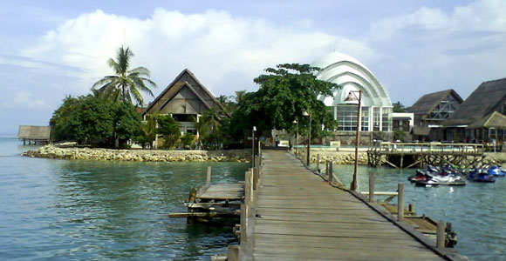

I’m Thinking of Ribs!
“Dad! As you were going home from Jakarta, I would like to order ribs from Hard Rock Café Jakarta!” Ribs, ribs, and ribs. What am I thinking? Guess what. I love ribs. Well, you guys maybe thinking that sirloin or tenderloin are better than ribs. But, for me, ribs are the best. Well, maybe you guys are thinking, where is my favorite place to eat ribs? The answer is simple. Hard Rock Café Jakarta.
Well, I know it’s a café, but this café is special. The foods are served well; especially the ribs are very tasty and yummy. The flavor of ribs will stick into your mouth like a parasite. It so yummy that you cant let go the taste of the ribs and you would lick the plate after you finish eating the ribs. The mix of barbeque sauce and the ribs make the power of the flavors stronger. I could see the ribs cooked perfectly by chef. I could smell the mixture of flavor of the ribs walking into my nose, and I could not handle myself from the smell of the ribs, I’ve been hypnotized by a ribs. I’m so fanatic to that ribs, or you could say it, ribs fever. The ribs were served with the crunchy and salty French fries, it was so awesome, you could eat ribs together with the ribs, so that you could taste the mix of the barbeque and the crunchy of French fries.
Ugh, as I read again this prompt, my stomach sounds like a blender. My throat is asking for the barbeque sauce and ribs. Ugh, I am so hungry! I would not let this precious ribs flowing inside other’s throat and I would not let this ribs blended in other’s stomach.

How to? I wanna be a billionaire

I am thinking that someday I will be the next billionaire. I’m thinking if I were a billionaire, I would buy anything in this world that is worth it for me. Um, I would buy tons of cars and houses for my family! But, I would not buy tons of foods, why? I’m not getting myself into heart disease and obesity. I could really smell tons of money in my precious wallet, I could feel the money sleeping my money, and I could see tons of money was crashing me everyday. But, I would not use my money for my own; I would spend my money to help others. I know it would be hard for me to spend my money to help others, but what can I do! God created us to help each other! So, I guess I would spend my money to help other (poverty and sickness).
But, what can I do to be a billionaire? 1st step: Collecting money in my own bank. Well, it will help. 2nd step: pray. I couldn’t be a billionaire if I’m not praying. The last step: hoping the dream comes true. Well! I know it’s quite hard to be a billionaire, but hoping is all I can do to be a billionaire. “If you want to be rich, don’t waste money by collecting shoes, or video games, or anything else. If you want to be rich, your collections are supposed to be money!” That is my mom’s advice for me!

Misery!!
“Oh no!! I just broke a lamp with my soccer ball! What should I do? Hiding the lamp and lie to my mom that the lamp been remove by my maid? No, it’s a bad idea! Telling the truth? It will make the situation worst! I have no idea!”
I was grade 1 and I was in a bad situation! I was still young and my mind was not as solid as myself today. I was a kid and I couldn’t think because I was in a bad situation!
I broke a lamp, my mother’s lovely lamp, and I felt my soul was being taken away! I was so speechless, I couldn’t speak, and my mind exploded for what just happened! I was walking around my house, trying to think what can I do to solve the problem, and in the end, I could only found a dead end. Oh, what a day!
My mom was in somewhere else, and I broke her lamp by playing soccer inside house. I was about to tell the truth to my mom, but I was so nervous as facing death! Well, my mom was scarier than my dad and my face was wet as the sweat coming down from my forehead like a river coming down from uphill. As I was standing at that time, I was lost in the middle of the jungle, meaning, I could only found a dead end.
“Beep! Beep!” I heard a sound of a car beeping in front of my house. “Aah! Maybe it’s my neighbor’s car beeping!” I said to myself. Then I looked outside, and… “I’m in a big trouble!!” It was my mother’s car! I had no time to clear the broken pieces of the lamp! I was trying to put away the broken pieces of the lamp far away from the “crime scene” as fast as I could like a person running in the runaway trying to reach the airplane before take off. I must hurry before my mom entered the gate of my house! “Whoa!!!” Luckily it was done before my mom entered my house. I put the ball away, and I became a soldier who was pretending to be a dead person to prevent himself from the enemy. I was pretending to sleep in the sofa hoping my mom didn’t recognize me.
“Govino!” Oh no! I was busted. I ignored the sound of my mother and kept pretending to sleep. In a sudden, my mom touched my hand and woke me up. “Oh no! What will happen next?” My mouth spoke in the darkness of my mind. “Hey! Hey! Wake up! Go upstairs and sleep in your room” What a feeling! I felt like I’ve ben release from the worst prison in the world. I felt free, I could finally breath fresh air after I breath a thick dirty air. I went upstairs with a sleepy face, trying to hide my face from the evil smiley face expression of myself and suddenly….
“Hey wait! Did you see my lamp?” Oh no, I’ve been thrown again to the prison from 10 seconds breathing fresh air. “Um, I didn’t see your lamp in the table, maybe it has been remove!” Hoping my mom would trust me. “But what are these pieces? Is it my lamp? And why is this ball inside my house? Did you just break my lamp?” Oh really! I’ve been really thrown into the interrogation room with electric shocks around me! I could not spoke anything! “Hey why are you silence? I’m asking, answer me please!” Now the electric shocks were really near my head!
“Okay! Okay! I broke your lamp by playing soccer at home, and I removed the broken pieces of the lamp inside cupboard.” I finally spoke the truth before the electric shock contracted with my head. “ I know you did it! Before I woke you up, I asked the maid where was my lamp, and they said that you broke the lamp by playing soccer at home! I’m just testing you if you would speak the truth!”
Gaah! I felt horrible; I had revenge to my maids at that time. I wanted to fire the maids but authority belonged to my mom, and I couldn’t do anything. I felt like I’ve been thrown to the prison because of them. My hands fisted behind, indicate that my revenge was truly real. But, in the other side the maids was speaking the truth. Of course, they wouldn’t hide my “bad” incident for my own goodness. They should spoke the truth my mom, because my mom was the master of them.
I realized that what I had done was very wrong. I shouldn’t hide anything from my mom because it got everything worst than before. Lying would not solve my problem but will get my problem worst. I should be afraid to tell the truth, why? Telling the truth would make my feeling peacefully.
So, what I learned from my experience was, don’t be afraid to tell the truth and don’t lie cause lying will make everything worst.
“I forgive you, but next time, you must not do the same thing again. This experience should be your lesson to be a better person. I forgive, but it doesn’t mean that I can forgive you all the time.” That was the first advice that changes my life into a better person.

MISERY!!!

