Math Real Life Problem

The topic for math real life problem is Mortgage. In this assessment, we need to purchase a house, and choose mortgages that are offered by the bank. There are 4 mortgages offered by the bank, loan A,loan B,loan C,loan D. Every loan has different offer (Annual Interest Rate and points/down payment). Our objective is to choose the cheapest monthly payment to pay the loan for 10 years. We need to calculate the loan one by one to get the cheapest monthly payment. To calculate monthly payment, we were given a formula. The formula is accurate and simple. We used the formula to calculate the monthly payment faster and accurate.

Loan | Annual Interest Rate | Points
Loan A | 6.25% | 4.00
Loan B | 6.50% | 2.75
Loan C | 6.75% | 1.75
Loan D | 7.25% | 0.00

Formula: ${m=A(1+\frac{r}{12})}^{Tx12}$
M= Monthly Payment
A=Leftover loan
R=Annual Interest (years)
T=Years
Steps to find the monthly payment
- Choose the house with it’s price
- Calculate the down payment
- Subtract the price of the house with the down payment to find the leftover
- Calculate the leftover with the given formula to find the monthly payment
- After finding the monthly payment for each loan, decide the cheapest loan.

Loan | Way
Loan A | Price of the house= Rp. 508 000 000  Points= 4%  Annual Interest=6.25% (expressed in decimal when calculating with the formula given)  Down Payment= 4% out of Rp. 508 000 000  Down Payment= Rp. 20 320 000  Leftover= Rp.487 680 000  Monthly payment= $\frac{{487 680 000(1+\frac{0.0625}{12})}^{120}}{120}$  Monthly payment= Rp. 7 580 246.63
Loan B | Price of the house= Rp. 508 000 000  Points= 2.75%  Annual Interest=6.50 (expressed in decimal when calculating with the formula given)  Down Payment= 2.75% out of Rp. 508 000 000  Down Payment= Rp. 13 970 000  Leftover= Rp.494 030 000  Monthly payment= $\frac{{494 030 000(1+\frac{0.0650}{12})}^{120}}{120}$  Monthly payment= Rp. 7 872 301.16
Loan C | price of the house= Rp. 508 000 000  Points= 1.75%  Annual Interest=6.75% (expressed in decimal when calculating with the formula given)  Down Payment= 1.75% out of Rp. 508 000 000  Down Payment= Rp.8 890 000  Leftover= Rp.499 110 000  Monthly payment= $\frac{{499 110 000(1+\frac{0.0675}{12})}^{120}}{120}$  Monthly payment= Rp. 8 153 468.51
Loan D | price of the house= Rp. 508 000 000  Points= 0.00%  Annual Interest=7.25% (expressed in decimal when calculating with the formula given)  Down Payment= 0.00% out of Rp. 508 000 000  Down Payment= Rp. 0  Leftover= Rp.508 000 000  Monthly payment= $\frac{{508 000 000(1+\frac{0.0725}{12})}^{120}}{120}$  Monthly payment= Rp. 8 721 649.49

By calculating each loan to find the monthly payment, I choose loan A. Loan A offers the cheapest monthly payment, which is Rp. 7 580 246.63. The lower the annual interest, and the higher the down payment, it will offers the cheapest monthly payment.

Reflection
I know that my answer is accurate because I justify my finding (monthly payment) with another way. The other way to justify my finding is by calculating in Microsoft excel. Excel also provides an accurate answer.
Steps to justify our finding in Microsoft Excel
- Choose the loan that offers the cheapest price of monthly installment
- Divide the annual interest the loan provide with 12 (12 represent 12 months, and the requirement states that we need to find monthly installment.) Then add it with 100%/1, because the payment is charged with the interest.
Loan A:$1+\frac{0.0625}{12}$

$= \frac{193}{192}$
3. Multiply the leftover of the loan with $\frac{193}{192}$
4. Multiply the result of the first calculation with $\frac{193}{192}$

5. Drag it down until number 120 because the requirement said that the loan offers monthly payment for 120 months.

6. Divide the last result of excel by 120 (for checking).

Steps with picture
1. 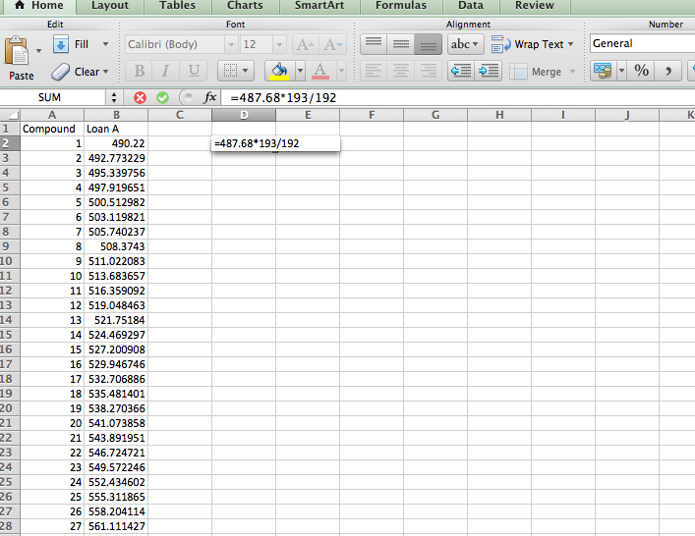

2.
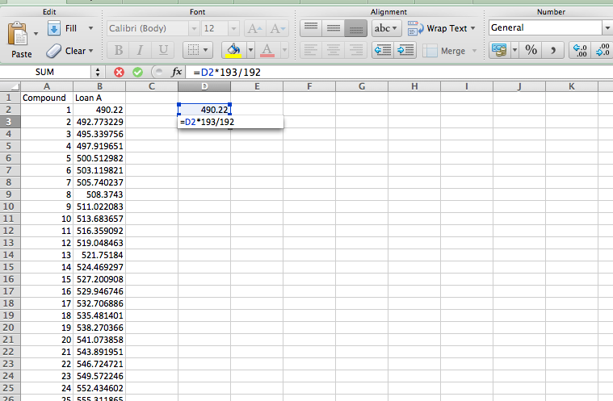
3.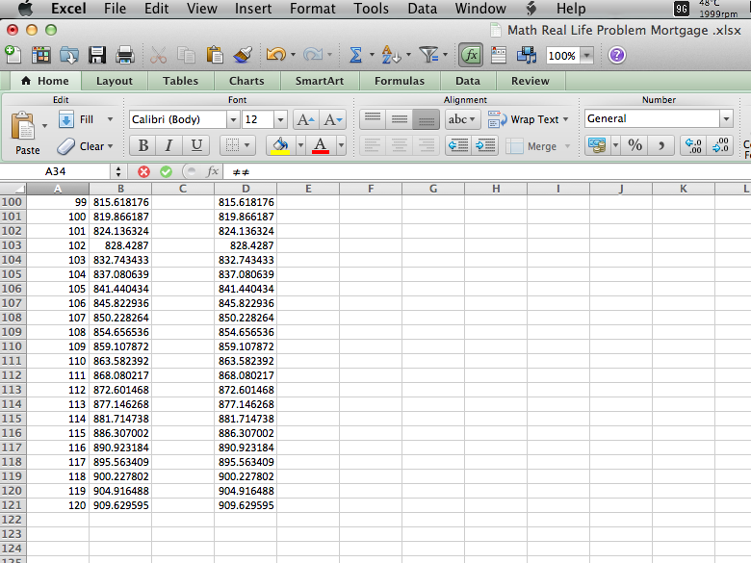

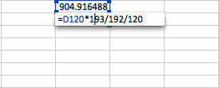
4.

Method 1 (Formula) | Method 2 (Excel Method)
- The formula offers a faster and easier calculation to find the monthly payment  - The formula offers not a really accurate result when you misspelled a number when doing the calculation  - The improvement that should be add to this formula is to add an alternative way if we misspelled a number when calculating to find the result. | 1. The second method offers a very accurate result  2. For someone who is new to Microsoft Excel, it is hard for them to use excel for calculating the result.  3. The second method offers a very fast calculating process

Relating it to Real Life
The result could be related real life when you need to pick a loan the bank offers. The result helps us to choose the cheapest loan the bank offers. We might need to pick a loan carefully, choosing the cheapest loan the bank offers. The result shows that the lower the annual interest, and the higher the down payment, it offers the cheapest loan and monthly installment.

