Journal:

In technology subject, we had a project. The project was making a website to promote Indonesia. I made the website by myself. These are the screenshots of the website:

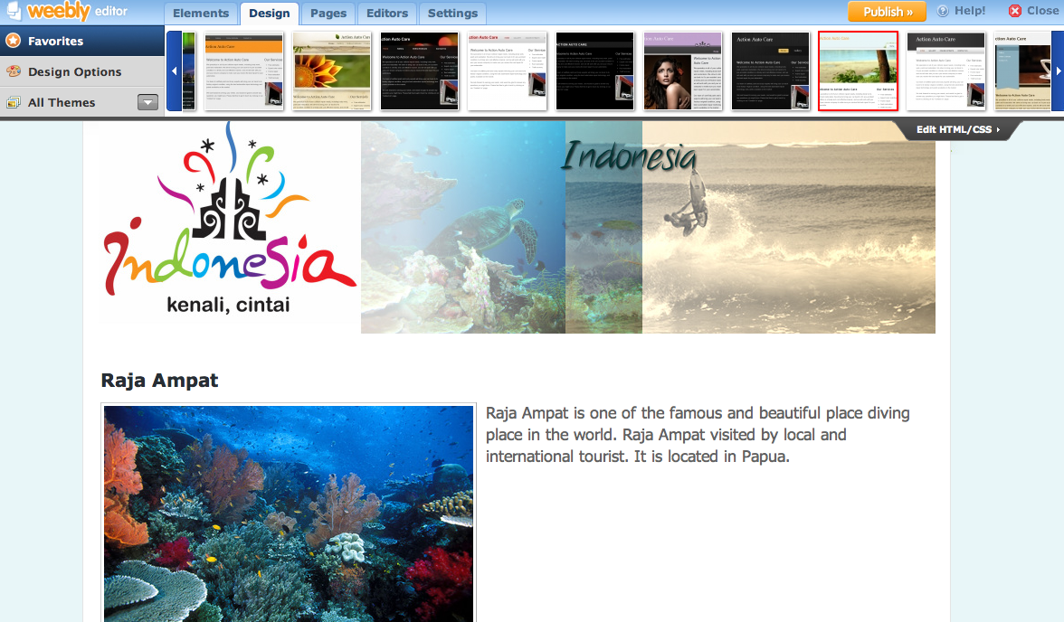

This screenshot is tourism place page. This page is to promote Indonesia tourism place.

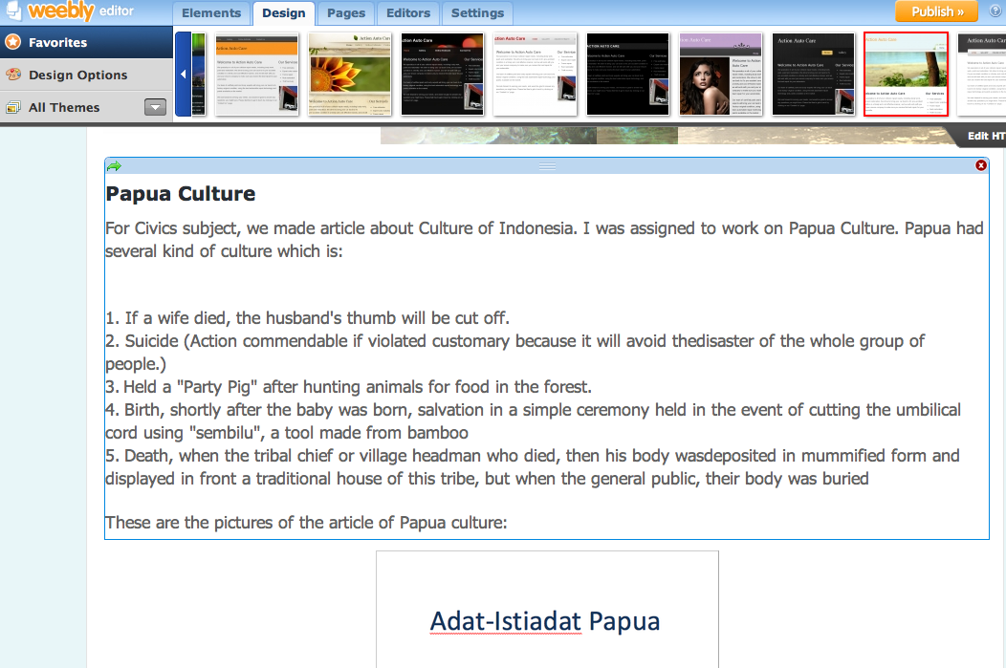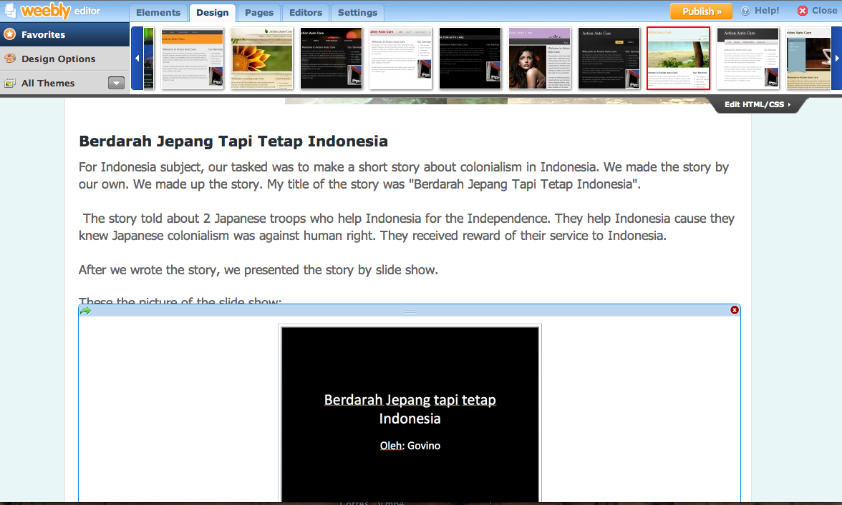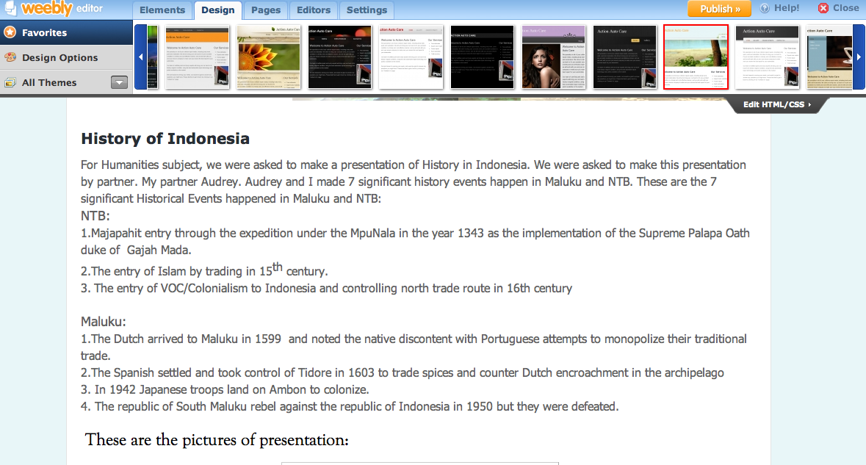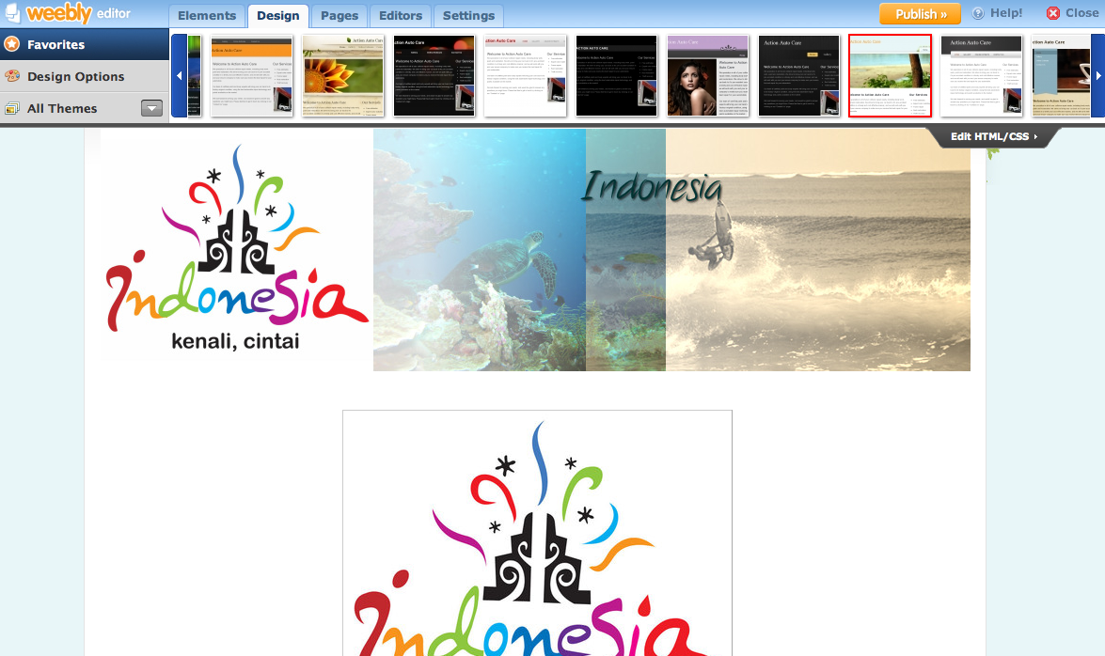

This is Civics page. This page is to reflect what I have done in Civics

1.What you do?

I find a source to help me design my website

2.What are the difficulties?

The difficulties are: managing time for making website and making good design for website

3.what are the supporting things?

The supporting things are: a source from Internet to help me build good design of website and a source from a book to help giving information in the website

4.How you finish this step?

I finish the step by looking up sources to help me build my website.

This is my Bahasa Indonesia page. This page is to reflect what I have done in Bahasa Indonesia subject.

This screenshot is humanities page. This page is to reflect what I have done in Humanities.

This homepage for the website.